Cross-field Auto Posture Correction Base on OpenPose and ChatGPT
Group: 78
EBU5608 Product Develoment and Management
Group Members:
<Shuntian Yao, QMUL ID: 210983074, BUPT ID: 2021213222 >(group leader)
<Wangzi Li, QMUL ID: 210983063, BUPT ID: 2021213221 >
<Yifan Cao, QMUL ID: 210986019, BUPT ID: 2021213228 >
<Ziang Wang, QMUL ID: 210985919, BUPT ID: 2021213208 >
<Yaqi Zhang, QMUL ID: 210986020, BUPT ID: 2021213229 >
Report Word Count: 2460 (except appendix and reference)

Table of Contents
Cross-field Auto Posture Correction Base on OpenPose and ChatGPT. 1
Summary of Responsibilities 3
Shuntian Yao (Group Leader) Contribution: <Opportunity Identification(3), IP Strategy(11), Appendix(13)> 3
Wangzi Li Contribution: <Identification of Customer Needs(7), List of References(12), Product Concept(9)> 3
Yifan Cao Contribution: < Mission Statement(6), Product Concept(9), Appendix(13)> 3
Ziang Wang Contribution: < Identification of Customer Needs(7), List of References(12), Product Concept(9)> 3
Yaqi Zhang Contribution: <Introduction(3), Conclusion(12), IP Strategy(11)> 3
Introduction 3
Opportunity Identification 3
Step 1: Establish a Charter: 3
Step 2: Generate and Sense Many Opportunities: 3
Step 3: Screen Opportunities: 4
Step 4: Develop Promising Opportunities: 4
Step5: Select exceptional opportunities: 5
Step6: Reflect on the results and the process: 5
Mission Statement 6
Function 6
Market 6
Identification of Customer Needs 7
Step1 Gather raw data from customers 7
Step2 Interpret the raw data in terms of customer needs 9
Step3 Organize the needs into a hierarchy of needs 9
Step4 Establish the relative importance of the needs 9
Product Concept 9
Realization of specific needs: 10
Profit method 11
IP Strategy 11
Conclusion 12
List of References 12
Appendix 13
The following code is a function for detecting human joints: 13
The following code is based on the result obtained from capturing a single frame image, and connects the body regions. 16
The following code is a function for visualizing the links between nodes in a graphical representation. 28
Questionnaire we made 29

Summary of Responsibilities

Shuntian Yao (Group Leader) Contribution: <Opportunity Identification(3), IP Strategy(11), Appendix(13)>

Wangzi Li Contribution: <Identification of Customer Needs(7), List of References(12), Product Concept(9)>

Yifan Cao Contribution: < Mission Statement(6), Product Concept(9), Appendix(13)>

Ziang Wang Contribution: < Identification of Customer Needs(7), List of References(12), Product Concept(9)>

Yaqi Zhang Contribution: <Introduction(3), Conclusion(12), IP Strategy(11)>

Introduction
With the rapid development of the times and the increasing digitization of life, our team is exploring the market in the field of digital health, focusing on the current standardized gap in the fitness market. We are developing a standardized fitness platform based on the OpenPose algorithm for posture recognition and chatGPT for human-machine interaction, to promote standardized and home-based fitness.

Opportunity Identification

Step 1: Establish a Charter:
Given the increasing popularity of the concept of health, there is a growing demand for real-time guidance in various fields, which we can design a platform to meet this demand and make great profit.

Step 2: Generate and Sense Many Opportunities:
- Currently, professional movement coaching charge high fees and lack sufficient expertise. (Consider implications of trends in lifestyles)
- Rehabilitation centers face a shortage of sports and health professionals. (Consider implications of trends in medical recovery field)
- Novice fitness enthusiasts and patients during rehabilitation may suffer from muscle injuries due to improper movements. (Gathered proactively from current customers)
- Difficult to find a professional movement coach with cross-disciplinary knowledge. (Gathered proactively from current customers)
- Fitness and rehabilitation activities often take place in unstable spare time, making it difficult to find a professional movement coach in a timely manner. (Gathered proactively from current customers)
- Verbal communication with the coach makes it hard to gauge muscle exertion in large groups like the back and hips. [1] (Gathered proactively from current customers
- The current development of technologies such as computer vision and kinematic modeling enables a scientific analysis of human movements. [2] (Track the status of emerging technologies)
- Large language models enable real-time professional guidance through cloud-based human interaction across multiple fields. (Track the status of emerging technologies)

Step 3: Screen Opportunities:
- Professional movement coaching charge high fees and lack sufficient expertise. (Web-based surveys)
- Rehabilitation centers face a shortage of sports and health professionals. (Web-based surveys)
- Difficult to find a professional movement coach with cross-disciplinary knowledge. (Web-based surveys)
- Fitness and rehabilitation activities often take place in unstable spare time, making it difficult to find a professional movement coach in a timely manner. (Web-based surveys)
- The current development of technologies such as computer vision and kinematic modeling enables a scientific analysis of human movements. (Workshops with multi-voting)
- Large language models enable real-time professional guidance through cloud-based human interaction across multiple fields. (Workshops with multi-voting)

Step 4: Develop Promising Opportunities:
Estimates of Market Sizes and Growth Rates:
Market for this product is a blue ocean as competitors lack this system.
Fitness trend is growing, expected to increase participation.
Customer Interviews:
Many avoid professional guidance for fitness and rehabilitation due to high costs, despite the risk of injury from incorrect movements.
Lack of knowledge in rehabilitation and fitness can lead to harmful practices like medication abuse and improper diet. [3]
People have unstable workout schedules due to the need to balance them with work.
Testing of Existing Products:
OpenPose project accurately detects human skeletal keypoints from RGB images.
Many mature datasets like COCO, Kinetics, NTU RGB+D, and UCF101 are available to train motion guidance models effectively. [4]
AIGC and large models like GPT can generate real-time action guidance for human interaction effectively.

Step5: Select exceptional opportunities:
- Is the opportunity real?
Questions to ask | Yes /  No
Is there a need? | Yes
Can the customer buy? | Yes
Will the customer buy? | Yes
Is there a viable concept for product already? | Yes
Is the product acceptable within the social, legal, and environmental norms? | Yes
Is the product feasible? Can it be made? Is the technology available? Does it  satisfy the needs? | Yes
Will our product satisfy the market? Is there a relative advantage to other  products? | Yes
Can it be produced at low cost? | Yes
Are the risks perceived by the customer acceptable? What are the barriers to  adoption? | Yes

- Can you win with this opportunity?
Questions to ask | Yes /  No
Do we have a competitive advantage? Is it sustainable? | Yes
Is the timing right? | Yes
Does it fit our brand? | Yes
Will we beat our competition? | Yes
Do we have superior resources? | Yes
Do we have the management that can win? | Yes
Do we know the market as well as or better than our competitors? | Yes

- Is it worth doing?
Questions to ask | Yes /  No
Will it make money? | Yes
Do we have the resources and the cash to do this? | Yes
Are the risks acceptable to us? | Yes
Does it fit our strategy? | Yes

Step6: Reflect on the results and the process:
- How many of the opportunities identified came from internal sources versus external sources?
About three forth from external sources.
- Did we consider dozens or hundreds of opportunities?
Take those opportunities we dropped and did not present on the report into account, total opportunities we considered is about 50.
- Was the innovation charter too narrowly focused?
No, it well fit the trends and the needs.
- Were our filtering criteria biased, or largely based on the best possible estimates of eventual product success?
Largely based on the best possible estimates of eventual product success.
- Are the resulting opportunities exciting to the team?
Definitely yes.

Mission Statement
Now that the fitness storm is surging, when the whole people have a deeper understanding of the concept of "fitness" and regard it as exercise and sports in their spare time, some crises have also quietly arrived. Non-standard movements have become the biggest killer of muscles rather than helpers. Many people have muscle strain or even injury due to non-standard movements. This project anchors the standardization gap in the current fitness market, and its purpose is to standardize movements to achieve fitness effects and effectively avoid muscle damage caused by excessive exercise. This project has promoted the standardization of fitness and home fitness, which is good for the positive feedback development of the fitness market. This project is committed to promoting the standardization of fitness, home-based fitness, and the positive feedback development of the fitness market.

Function
Develop a self-made wireless RGB-D camera based on the OpenPose algorithm for human body posture recognition and equipped with ESP32-CAM+ D435i[5]. Can achieve:
1. By building on the mobile phone, consumers can exercise and guide without limitation of venue and time.
2. Precisely correct the fitness posture to avoid damage to muscles and joints.
3. Correct posture problems such as pelvic forward tilt, neck forward tilt, hunchback, etc.
4. Personalize diet according to needs.

Market
People with fitness needs.
People who have little spare time and cannot control freely, such as professionals, students, etc.
People who do not have the economic and time conditions to go to the gym to hire a personal trainer.
People in need of rehabilitation.

Identification of Customer Needs
We use the Ulrich and Eppinger's five-steps process to identify customer needs for our product.

Step1 Gather raw data from customers
We distributed questionnaires through social media, and finally obtained 500 sample data, the following is the data chart.
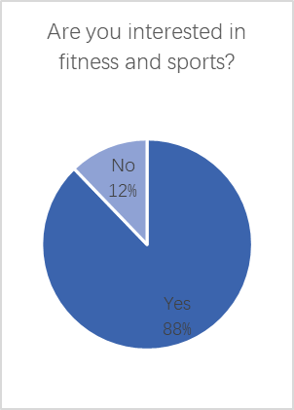 | 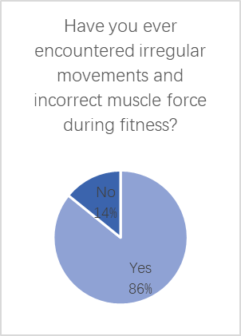 | 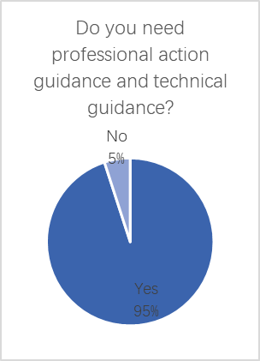
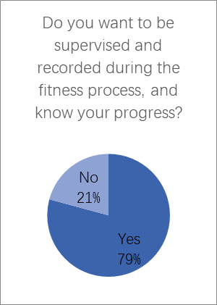 | 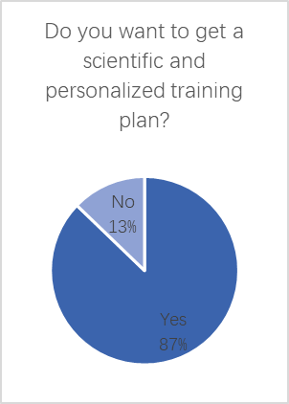 | 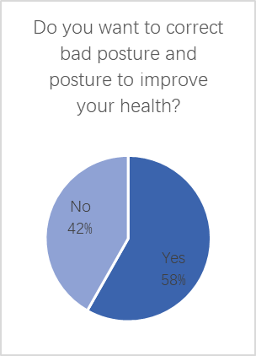
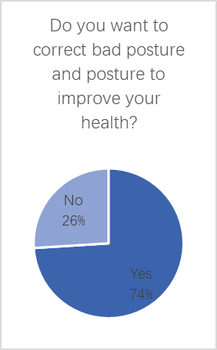 | 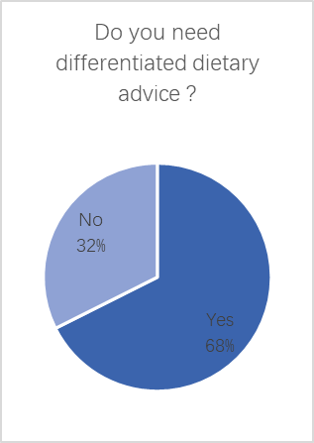 | 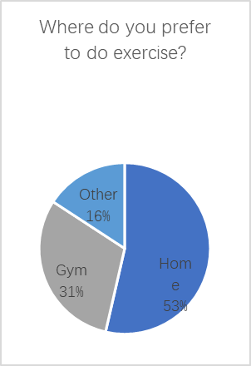
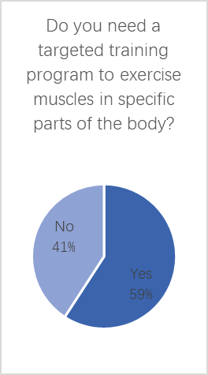 | 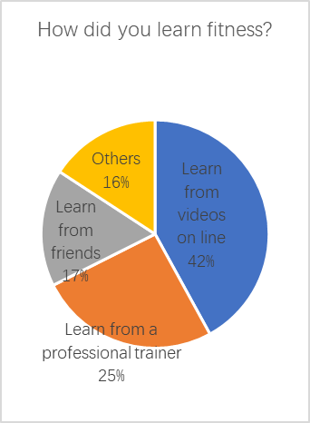 | 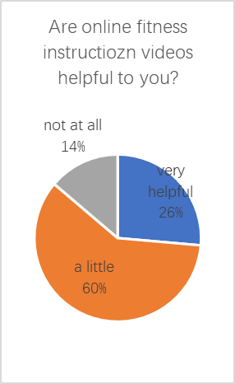
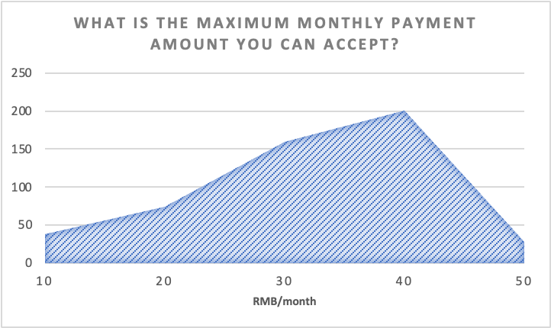

Step2 Interpret the raw data in terms of customer needs
Survey data indicates 90% of respondents struggle with non-standard movements and incorrect exertion during fitness, highlighting the need for correct movement and muscle exertion guidance.
Over 50% exercise at home, and almost 70% lack professional trainer guidance. Online fitness videos are perceived as unhelpful, underscoring the need for professional guidance.
Approximately 80% of respondents desire fitness process recording and motion supervision, based on the data. Hence, motion supervision and process recording are crucial user needs.
Approximately 60% of users require targeted muscle exercise and 90% require customized training plans, highlighting the importance of personalized and scientific training programs.
58% of respondents reported bad posture and desire correction, highlighting the need for auxiliary posture correction.
68% of respondents require customized dietary advice for specific needs like muscle gain and fat loss, hence personalized dietary recommendations are customer needs.
When the price exceeds 30 yuan per month, more than half of the consumers cannot accept it, so relatively low pricing is one of the needs of consumers

Step3 Organize the needs into a hierarchy of needs
1. Relatively low pricing.
2. Professional action guidance.
3. Judging whether the movement and muscle force are correct.
4. Auxiliary correction of bad posture.
5. Sports supervision and process recording.
6. Personalized diet recommendations.

Step4 Establish the relative importance of the needs
Relatively low pricing strategy is more important than complete functions.
Professional action guidance is more important than process recording.
Auxiliary correction of bad posture is more important than personalized diet recommendations.

Product Concept
Based on customer needs, we can establish target specifications
customer need | metric | value of this metric
Can't afford to go to the gym to find a personal trainer | cost | 25 yuan per month to unlock all functions
Use fragmentation time to exercise | time available to exercise | Can choose any time period and be free
Can correct fitness posture to avoid injury | technical support | Accurate online correction of fitness posture based on openpose and posture recognition
Hope to experience more fitness projects | Types of fitness programs | Rich in variety and can be enjoyed simultaneously across different fields

Realization of specific needs:
1. The communication of action guidance is often only based on verbal forms, and it is often difficult to feel the state of muscle strength, especially the back, arms and other large muscle groups. To meet the needs of precise correction of the user's fitness posture, the cross-domain automatic posture correction technology can monitor the posture of the human body through real-time video or image recognition, and provide real-time feedback. Consumers can use the technology to improve their posture and visually see if it is correct, so they can better feel the state of their muscles, especially for large muscle groups such as back and hips. We provide a pose recognition algorithm and matching algorithm to recognize and estimate the pose of the human body's skeletal joints[6]. At the same time, we designed some indicators to show whether an action or posture is in place or achieves the expected fitness effect. See the appendix for relevant codes.
2. Due to time or space constraints, some people cannot find professional action guidance: cross-domain automatic posture correction technology can provide consumers with posture correction anytime and anywhere. In this way, consumers can practice fitness or rehab in their own time and place, without having to take into account the time constraints of professional guidance. Customers can also experience a variety of fitness methods at a low price and find the most suitable fitness program for them.
3. Personalized diet. Through the classification of consumer needs, such as muscle-building consumers, fat-reducing consumers, and sedentary consumers, personalized diet customization can help meet consumer needs.

Profit method
1. Equipped on the fitness platform to achieve further promotion.
2. High-quality fitness courses at low prices.
3. Low-cost action guidance.
4. Advertising on the platform.
5. Sales of related health care and fitness products.

IP Strategy
Identify any possible assets that you may create during this project and which intellectual property rights (IPRs) will be able to protect them：
- The platform design and its unique content, including user interface, features, functions, and the platform's proprietary interdisciplinary exercise guide and diet plan, may be protected by copyright.
- The platform's name, logo, and any potential derivative branding may be protected as trademarks to prevent competitors from using them without authorization.
- The chatbot technology that enables real-time interaction between users and the platform may be eligible for patent protection, or may be protected as a trade secret.
- The Openpose technology that provides users with real-time muscle activation feedback, its algorithms and formulas, may be protected as a trade secret.
Consider whether you may also need to use, and therefore license, any third-party assets or content.：
- The platform needs to use OpenPose as a third-party image recognition technology, which requires compliance with the provisions and licensing requirements of the BSD 3-Clause License (OpenPose is an open-source project that uses the BSD 3-Clause License), and comply with legal and ethical standards.[7]
- The platform needs to use third-party content or media, which requires obtaining relevant licenses or authorizations. For example, for advertising or selling fitness products on the platform, licenses or authorizations from advertisers or suppliers are required.
- The platform trains a model to replace fitness personnel, which requires a large dataset so that the model can accurately recognize various movements and provide correct guidance. Available datasets include COCO dataset, Kinetics dataset, NTU RGB+D dataset, UCF101 dataset, and so on[4].
- The platform needs to collect users' personal information and data, which requires compliance with data protection regulations, obtaining relevant licenses or authorizations, and obtaining explicit consent from users. At the same time, appropriate security measures need to be taken to prevent data leakage and abuse.
- The platform needs professionals to provide fitness guidance or postpartum recovery, and provide their relevant certifications.

Conclusion
Cross-field Auto Posture Correction Based on OpenPose and ChatGPT is a promising product that provides real-time posture detection and technique consultation for fitness enthusiasts, postpartum rehabilitation, and rehabilitation patients, filling the gap in the standardization of the current fitness market. Secondly, with the increasing awareness of health and the gradual development of the fitness industry, the market demand for such products is gradually increasing. Detailed survey data can be found in the Identify Customer Needs section. The product is suitable for individual consumers, commercial fitness institutions, and hospitals and sanatoriums with rehabilitation needs, with broad market prospects. Furthermore, the platform attempts to advertise and sell products, which is a very attractive marketing channel for relevant brands and merchants. This helps to increase the platform's revenue sources, provide more stable economic support for the platform's continuous development, and further unleash the platform's market potential.
However, the product still has some shortcomings that need to be improved:
Accuracy issues: Sensor accuracy and algorithm model optimization are the core issues that this product needs to solve. If the error is too large, it will affect the user's fitness effect and reduce the user's trust.
Incomplete open-source project technology and infrequent iteration: In the OpenPose technology, the detection accuracy may be affected when facial and hand regions are occluded[8].
Cost control issues: Balancing the relationship between product positioning and cost control is also a major challenge. It is possible to consider using more efficient devices for model operation or optimizing the model structure to minimize the number of model parameters and computational costs while ensuring accuracy to the maximum extent.
Low entry threshold: Using open-source technology frequently, the entry threshold is low, and continuous research and development and optimization of one's own technology are required to achieve market share through product features and brand building.

List of References

- Chen, Karen B., et al. "Virtual exertions: Evoking the sense of exerting forces in virtual reality using gestures and muscle activity." Human factors 57.4 (2015): 658-673.
- Li, Renjie, et al. "Moving towards intelligent telemedicine: Computer vision measurement of human movement." Computers in Biology and Medicine 147 (2022): 105776.
- Herbst, Karen L., and Shalender Bhasin. "Testosterone action on skeletal muscle." Current Opinion in Clinical Nutrition & Metabolic Care 7.3 (2004): 271-277.
- Zhu, Jiagang, et al. "Action machine: Rethinking action recognition in trimmed videos." arXiv preprint arXiv:1812.05770 (2018).
- Cao, Zhe, et al. "Realtime multi-person 2d pose estimation using part affinity fields." Proceedings of the IEEE conference on computer vision and pattern recognition. 2017.
- Yang, Lei, et al. "Human exercise posture analysis based on Pose estimation." 2021 IEEE 5th Advanced Information Technology, Electronic and Automation Control Conference (IAEAC). Vol. 5. IEEE, 2021.
- Sinclair, Andrew. "License Profile: BSD." IFOSS L. Rev. 2 (2010): 1.
- Chen, Weiming, et al. "Fall detection based on key points of human-skeleton using openpose." Symmetry 12.5 (2020): 744.

Appendix

The following code is a function for detecting human joints:
void nms(BlobData* bottom_blob, BlobData* top_blob, float threshold){

int w = bottom_blob->width;
int h = bottom_blob->height;
int plane_offset = w * h;
float* ptr = bottom_blob->list;
float* top_ptr = top_blob->list;
int top_plane_offset = top_blob->width * top_blob->height;
int max_peaks = top_blob->height - 1;

for (int n = 0; n < bottom_blob->num; ++n){
for (int c = 0; c < bottom_blob->channels - 1; ++c){

int num_peaks = 0;
for (int y = 1; y < h - 1 && num_peaks != max_peaks; ++y){
for (int x = 1; x < w - 1 && num_peaks != max_peaks; ++x){
float value = ptr[y*w + x];
if (value > threshold){
const float topLeft = ptr[(y - 1)*w + x - 1];
const float top = ptr[(y - 1)*w + x];
const float topRight = ptr[(y - 1)*w + x + 1];
const float left = ptr[y*w + x - 1];
const float right = ptr[y*w + x + 1];
const float bottomLeft = ptr[(y + 1)*w + x - 1];
const float bottom = ptr[(y + 1)*w + x];
const float bottomRight = ptr[(y + 1)*w + x + 1];

if (value > topLeft && value > top && value > topRight
&& value > left && value > right
&& value > bottomLeft && value > bottom && value > bottomRight)
{
float xAcc = 0;
float yAcc = 0;
float scoreAcc = 0;
for (int kx = -3; kx <= 3; ++kx){
int ux = x + kx;
if (ux >= 0 && ux < w){
for (int ky = -3; ky <= 3; ++ky){
int uy = y + ky;
if (uy >= 0 && uy < h){
float score = ptr[uy * w + ux];
xAcc += ux * score;
yAcc += uy * score;
scoreAcc += score;
}
}
}
}

xAcc /= scoreAcc;
yAcc /= scoreAcc;
scoreAcc = value;
top_ptr[(num_peaks + 1) * 3 + 0] = xAcc;
top_ptr[(num_peaks + 1) * 3 + 1] = yAcc;
top_ptr[(num_peaks + 1) * 3 + 2] = scoreAcc;
num_peaks++;
}
}
}
}
top_ptr[0] = num_peaks;
ptr += plane_offset;
top_ptr += top_plane_offset;
}
}
}

The following code is based on the result obtained from capturing a single frame image, and connects the body regions.
void connectBodyPartsCpu(vector<float>& poseKeypoints, const float* const heatMapPtr, const float* const peaksPtr,
const Size& heatMapSize, const int maxPeaks, const int interMinAboveThreshold,
const float interThreshold, const int minSubsetCnt, const float minSubsetScore, const float scaleFactor, vector<int>& keypointShape)
{
keypointShape.resize(3);
const std::vector<unsigned int> POSE_COCO_PAIRS{ 1, 2, 1, 5, 2, 3, 3, 4, 5, 6, 6, 7, 1, 8, 8, 9, 9, 10, 1, 11, 11, 12, 12, 13, 1, 0, 0, 14, 14, 16, 0, 15, 15, 17, 2, 16, 5, 17 };
const std::vector<unsigned int> POSE_COCO_MAP_IDX{ 31, 32, 39, 40, 33, 34, 35, 36, 41, 42, 43, 44, 19, 20, 21, 22, 23, 24, 25, 26, 27, 28, 29, 30, 47, 48, 49, 50, 53, 54, 51, 52, 55, 56, 37, 38, 45, 46 };
const auto& bodyPartPairs = POSE_COCO_PAIRS;
const auto& mapIdx = POSE_COCO_MAP_IDX;
const auto numberBodyParts = 18;

const auto numberBodyPartPairs = bodyPartPairs.size() / 2;

std::vector<std::pair<std::vector<int>, double>> subset; // Vector<int> = Each body part + body parts counter; double = subsetScore
const auto subsetCounterIndex = numberBodyParts;
const auto subsetSize = numberBodyParts + 1;

const auto peaksOffset = 3 * (maxPeaks + 1);
const auto heatMapOffset = heatMapSize.area();

for (auto pairIndex = 0u; pairIndex < numberBodyPartPairs; pairIndex++)
{
const auto bodyPartA = bodyPartPairs[2 * pairIndex];
const auto bodyPartB = bodyPartPairs[2 * pairIndex + 1];
const auto* candidateA = peaksPtr + bodyPartA*peaksOffset;
const auto* candidateB = peaksPtr + bodyPartB*peaksOffset;
const auto nA = intRound(candidateA[0]);
const auto nB = intRound(candidateB[0]);

// add parts into the subset in special case
if (nA == 0 || nB == 0)
{
// Change w.r.t. other
if (nA == 0) // nB == 0 or not
{
for (auto i = 1; i <= nB; i++)
{
bool num = false;
const auto indexB = bodyPartB;
for (auto j = 0u; j < subset.size(); j++)
{
const auto off = (int)bodyPartB*peaksOffset + i * 3 + 2;
if (subset[j].first[indexB] == off)
{
num = true;
break;
}
}
if (!num)
{
std::vector<int> rowVector(subsetSize, 0);
rowVector[bodyPartB] = bodyPartB*peaksOffset + i * 3 + 2; //store the index
rowVector[subsetCounterIndex] = 1; //last number in each row is the parts number of that person
const auto subsetScore = candidateB[i * 3 + 2]; //second last number in each row is the total score
subset.emplace_back(std::make_pair(rowVector, subsetScore));
}
}
}
else // if (nA != 0 && nB == 0)
{
for (auto i = 1; i <= nA; i++)
{
bool num = false;
const auto indexA = bodyPartA;
for (auto j = 0u; j < subset.size(); j++)
{
const auto off = (int)bodyPartA*peaksOffset + i * 3 + 2;
if (subset[j].first[indexA] == off)
{
num = true;
break;
}
}
if (!num)
{
std::vector<int> rowVector(subsetSize, 0);
rowVector[bodyPartA] = bodyPartA*peaksOffset + i * 3 + 2; //store the index
rowVector[subsetCounterIndex] = 1; //last number in each row is the parts number of that person
const auto subsetScore = candidateA[i * 3 + 2]; //second last number in each row is the total score
subset.emplace_back(std::make_pair(rowVector, subsetScore));
}
}
}
}
else // if (nA != 0 && nB != 0)
{
std::vector<std::tuple<double, int, int>> temp;
const auto numInter = 10;
const auto* const mapX = heatMapPtr + mapIdx[2 * pairIndex] * heatMapOffset;
const auto* const mapY = heatMapPtr + mapIdx[2 * pairIndex + 1] * heatMapOffset;
for (auto i = 1; i <= nA; i++)
{
for (auto j = 1; j <= nB; j++)
{
const auto dX = candidateB[j * 3] - candidateA[i * 3];
const auto dY = candidateB[j * 3 + 1] - candidateA[i * 3 + 1];
const auto normVec = float(std::sqrt(dX*dX + dY*dY));
// If the peaksPtr are coincident. Don't connect them.
if (normVec > 1e-6)
{
const auto sX = candidateA[i * 3];
const auto sY = candidateA[i * 3 + 1];
const auto vecX = dX / normVec;
const auto vecY = dY / normVec;

auto sum = 0.;
auto count = 0;
for (auto lm = 0; lm < numInter; lm++)
{
const auto mX = fastMin(heatMapSize.width - 1, intRound(sX + lm*dX / numInter));
const auto mY = fastMin(heatMapSize.height - 1, intRound(sY + lm*dY / numInter));
//checkGE(mX, 0, "", __LINE__, __FUNCTION__, __FILE__);
//checkGE(mY, 0, "", __LINE__, __FUNCTION__, __FILE__);
const auto idx = mY * heatMapSize.width + mX;
const auto score = (vecX*mapX[idx] + vecY*mapY[idx]);
if (score > interThreshold)
{
sum += score;
count++;
}
}

// parts score + connection score
if (count > interMinAboveThreshold)
temp.emplace_back(std::make_tuple(sum / count, i, j));
}
}
}

// select the top minAB connection, assuming that each part occur only once
// sort rows in descending order based on parts + connection score
if (!temp.empty())
std::sort(temp.begin(), temp.end(), std::greater<std::tuple<float, int, int>>());

std::vector<std::tuple<int, int, double>> connectionK;

const auto minAB = fastMin(nA, nB);
std::vector<int> occurA(nA, 0);
std::vector<int> occurB(nB, 0);
auto counter = 0;
for (auto row = 0u; row < temp.size(); row++)
{
const auto score = std::get<0>(temp[row]);
const auto x = std::get<1>(temp[row]);
const auto y = std::get<2>(temp[row]);
if (!occurA[x - 1] && !occurB[y - 1])
{
connectionK.emplace_back(std::make_tuple(bodyPartA*peaksOffset + x * 3 + 2,
bodyPartB*peaksOffset + y * 3 + 2,
score));
counter++;
if (counter == minAB)
break;
occurA[x - 1] = 1;
occurB[y - 1] = 1;
}
}

// Cluster all the body part candidates into subset based on the part connection
// initialize first body part connection 15&16
if (pairIndex == 0)
{
for (const auto connectionKI : connectionK)
{
std::vector<int> rowVector(numberBodyParts + 3, 0);
const auto indexA = std::get<0>(connectionKI);
const auto indexB = std::get<1>(connectionKI);
const auto score = std::get<2>(connectionKI);
rowVector[bodyPartPairs[0]] = indexA;
rowVector[bodyPartPairs[1]] = indexB;
rowVector[subsetCounterIndex] = 2;
// add the score of parts and the connection
const auto subsetScore = peaksPtr[indexA] + peaksPtr[indexB] + score;
subset.emplace_back(std::make_pair(rowVector, subsetScore));
}
}
// Add ears connections (in case person is looking to opposite direction to camera)
else if (pairIndex == 17 || pairIndex == 18)
{
for (const auto& connectionKI : connectionK)
{
const auto indexA = std::get<0>(connectionKI);
const auto indexB = std::get<1>(connectionKI);
for (auto& subsetJ : subset)
{
auto& subsetJFirst = subsetJ.first[bodyPartA];
auto& subsetJFirstPlus1 = subsetJ.first[bodyPartB];
if (subsetJFirst == indexA && subsetJFirstPlus1 == 0)
subsetJFirstPlus1 = indexB;
else if (subsetJFirstPlus1 == indexB && subsetJFirst == 0)
subsetJFirst = indexA;
}
}
}
else
{
if (!connectionK.empty())
{
// A is already in the subset, find its connection B
for (auto i = 0u; i < connectionK.size(); i++)
{
const auto indexA = std::get<0>(connectionK[i]);
const auto indexB = std::get<1>(connectionK[i]);
const auto score = std::get<2>(connectionK[i]);
auto num = 0;
for (auto j = 0u; j < subset.size(); j++)
{
if (subset[j].first[bodyPartA] == indexA)
{
subset[j].first[bodyPartB] = indexB;
num++;
subset[j].first[subsetCounterIndex] = subset[j].first[subsetCounterIndex] + 1;
subset[j].second = subset[j].second + peaksPtr[indexB] + score;
}
}
// if can not find partA in the subset, create a new subset
if (num == 0)
{
std::vector<int> rowVector(subsetSize, 0);
rowVector[bodyPartA] = indexA;
rowVector[bodyPartB] = indexB;
rowVector[subsetCounterIndex] = 2;
const auto subsetScore = peaksPtr[indexA] + peaksPtr[indexB] + score;
subset.emplace_back(std::make_pair(rowVector, subsetScore));
}
}
}
}
}
}

// Delete people below the following thresholds:
// a) minSubsetCnt: removed if less than minSubsetCnt body parts
// b) minSubsetScore: removed if global score smaller than this
// c) POSE_MAX_PEOPLE: keep first POSE_MAX_PEOPLE people above thresholds
auto numberPeople = 0;
std::vector<int> validSubsetIndexes;
validSubsetIndexes.reserve(fastMin((size_t)POSE_MAX_PEOPLE, subset.size()));
for (auto index = 0u; index < subset.size(); index++)
{
const auto subsetCounter = subset[index].first[subsetCounterIndex];
const auto subsetScore = subset[index].second;
if (subsetCounter >= minSubsetCnt && (subsetScore / subsetCounter) > minSubsetScore)
{
numberPeople++;
validSubsetIndexes.emplace_back(index);
if (numberPeople == POSE_MAX_PEOPLE)
break;
}
else if (subsetCounter < 1)
printf("Bad subsetCounter. Bug in this function if this happens. %d, %s, %s", __LINE__, __FUNCTION__, __FILE__);
}

// Fill and return poseKeypoints
keypointShape = { numberPeople, (int)numberBodyParts, 3 };
if (numberPeople > 0)
poseKeypoints.resize(numberPeople * (int)numberBodyParts * 3);
else
poseKeypoints.clear();

for (auto person = 0u; person < validSubsetIndexes.size(); person++)
{
const auto& subsetI = subset[validSubsetIndexes[person]].first;
for (auto bodyPart = 0u; bodyPart < numberBodyParts; bodyPart++)
{
const auto baseOffset = (person*numberBodyParts + bodyPart) * 3;
const auto bodyPartIndex = subsetI[bodyPart];
if (bodyPartIndex > 0)
{
poseKeypoints[baseOffset] = peaksPtr[bodyPartIndex - 2] * scaleFactor;
poseKeypoints[baseOffset + 1] = peaksPtr[bodyPartIndex - 1] * scaleFactor;
poseKeypoints[baseOffset + 2] = peaksPtr[bodyPartIndex];
}
else
{
poseKeypoints[baseOffset] = 0.f;
poseKeypoints[baseOffset + 1] = 0.f;
poseKeypoints[baseOffset + 2] = 0.f;
}
}
}
}

The following code is a function for visualizing the links between nodes in a graphical representation.
void renderPoseKeypointsCpu(Mat& frame, const vector<float>& poseKeypoints, vector<int> keyshape,
const float renderThreshold, float scale, const bool blendOriginalFrame = true)
{
// Background
if (!blendOriginalFrame)
frame.setTo(0.f); // [0-255]

// Parameters
const auto thicknessCircleRatio = 1.f / 75.f;
const auto thicknessLineRatioWRTCircle = 0.75f;
const auto& pairs = POSE_COCO_PAIRS_RENDER;

// Render keypoints
renderKeypointsCpu(frame, poseKeypoints, keyshape, pairs, POSE_COCO_COLORS_RENDER, thicknessCircleRatio,
thicknessLineRatioWRTCircle, renderThreshold, scale);
}
In human pose recognition algorithms, we mainly utilize real-time input of images, search for feature points, match them with keypoints, optimize the labeling, and then perform line visualization processing.

Questionnaire we made
1. Are you interested in fitness and sports?
2. Do you need professional action guidance and technical guidance to ensure that your exercise posture is correct and safe?
3. Have you ever encountered problems such as irregular movements and incorrect muscle force in fitness and rehabilitation?
4. Do you want to be supervised and recorded during the fitness process, and know your progress?
5. Do you want to get a scientific and personalized training plan to help you achieve your health and beauty goals?
6. Do you want to correct bad posture and posture to improve your health?
7. Do you need differentiated dietary advice to meet the needs of different groups of people, such as muscle gain, fat loss, etc.?
8. Do you have other needs and suggestions related to fitness and sports?
9. Do you need regular feedback and improvement suggestions for sports training?
10. What is the maximum monthly payment amount you can accept?
11. Do you prefer to do sports training at home, or do you prefer to go to the gym and other places?
12. Do you need to exchange experience and share training results with other fitness enthusiasts?
13. Do you need a targeted training program to address certain body parts, such as butt lifts, abs training, etc.?

